Contents

**Hola Mohalla: A Festival of Sikh Valor and Spirit** 1

**Introduction** 1

**Historical Background** 1

**Origin of Hola Mohalla** 1

**Martial and Spiritual Significance** 1

**Modern-Day Celebrations** 1

**Anandpur Sahib and Global Observances** 1

**Conclusion** 2

**References** 2

**Hola Mohalla: A Festival of Sikh Valor and Spirit**

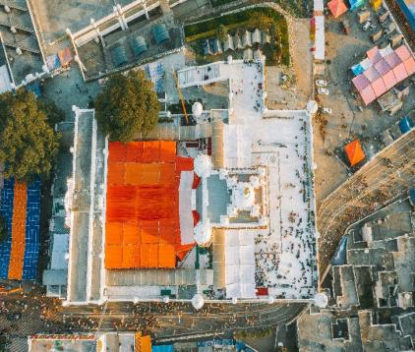**Introduction**

Hola Mohalla (also spelled as Hola Mahalla) is a significant Sikh festival celebrated with great enthusiasm primarily in the Indian state of Punjab. It was introduced by Guru Gobind Singh, the tenth Sikh Guru, as a day for the Sikhs to demonstrate their martial skills in simulated battles. The festival usually falls a day after the Hindu festival of Holi, symbolizing a more disciplined and warrior-like expression of celebration.

**Historical Background**

**Origin of Hola Mohalla**

Hola Mohalla was first organized in 1701 by Guru Gobind Singh at Anandpur Sahib. The term “Hola” is derived from the word “Holi”, while “Mohalla” refers to an organized procession or march. Unlike Holi, which is associated with color and revelry, Hola Mohalla was envisioned as a day for Sikhs to exhibit bravery, unity, and martial discipline.

Guru Gobind Singh aimed to transform the playful celebration of Holi into an occasion that inspired martial readiness and religious devotion among Sikhs. The festival became a gathering of the Khalsa, the Sikh warrior community, who performed mock battles, practiced weaponry, and recited poetry of valor.

**Martial and Spiritual Significance**

The mock battles and martial displays, known as *Gatka* (a traditional Sikh martial art), serve both as training and as a reminder of the Sikh principle of **"Sant-Sipahi"** — the Saint-Soldier ideal. These displays include horse-riding, sword-fighting, and acrobatics, emphasizing physical strength, courage, and the readiness to fight injustice.

At the same time, the event retains its religious undertone. Devotees listen to *kirtans* (devotional music), *katha* (spiritual discourse), and participate in *langar* (community kitchens), reflecting Sikh values of equality, service, and community bonding.

**Modern-Day Celebrations**

**Anandpur Sahib and Global Observances**

The town of Anandpur Sahib remains the epicenter of Hola Mohalla festivities. Thousands of Sikhs from across India and abroad converge here to witness and participate in the processions, performances, and religious gatherings.

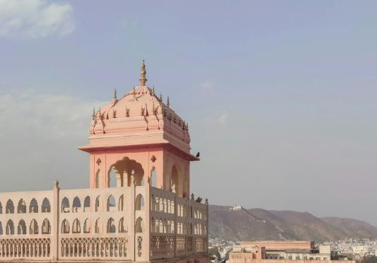The festival lasts three days and includes:

* **Shastra Darshan** (exhibition of weapons)
* **Mock battles and martial arts**
* **Poetry readings**
* **Kirtan and recitations**
* **Langar for all**

Beyond Punjab, Hola Mohalla is also observed in Sikh diaspora communities in the UK, Canada, and the United States, keeping the spirit of Guru Gobind Singh alive across generations and geographies.

**Conclusion**

Hola Mohalla stands as a unique celebration that blends religious devotion with martial spirit. It is a reminder of the valorous legacy of the Sikhs, the teachings of Guru Gobind Singh, and the continuous commitment of the community to stand for justice and righteousness. In a world often divided by narrow identities, Hola Mohalla offers a model of unity, service, and strength in diversity.

**References**

1. Singh, Khushwant. *A History of the Sikhs: Volume 1: 1469-1839*. Oxford University Press, 2004.
2. Takhar, Opinderjit Kaur. *Sikh Identity: An Exploration of Groups Among Sikhs*. Routledge, 2005.
3. Singh, Nikky-Guninder Kaur. *The Name of My Beloved: Verses of the Sikh Gurus*. HarperCollins India, 2001.